

LAB REPORT 01

SUBMITTED TO : MR. MUBASHIR IQBAL
SUBMITTED BY: AHMED SALEEM RANA
REG ID: 24-CYS-023
SECTION : B
COURSE TITLE: ARTIFACIAL INTEELLIGENCE LAB

HITEC UNIVERSITY, TAXILA CANTT

TASK 01

Write a Python Code to write the table of a number given by the user?

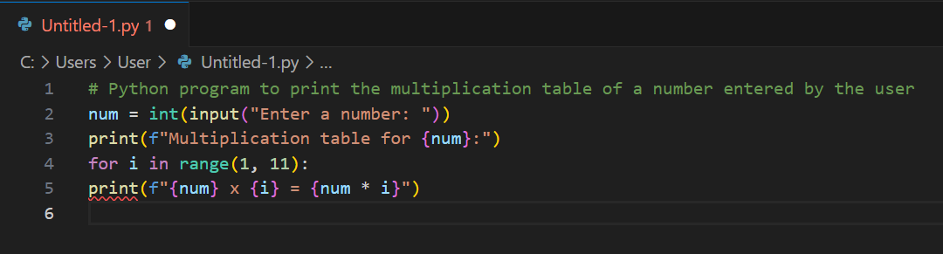
INPUT:

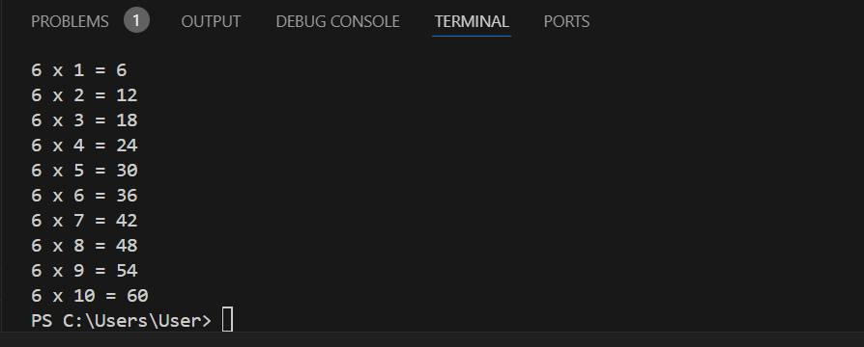
OUTPUT:

TASK 02

Write a python code to check wheatear a number is prime or not?
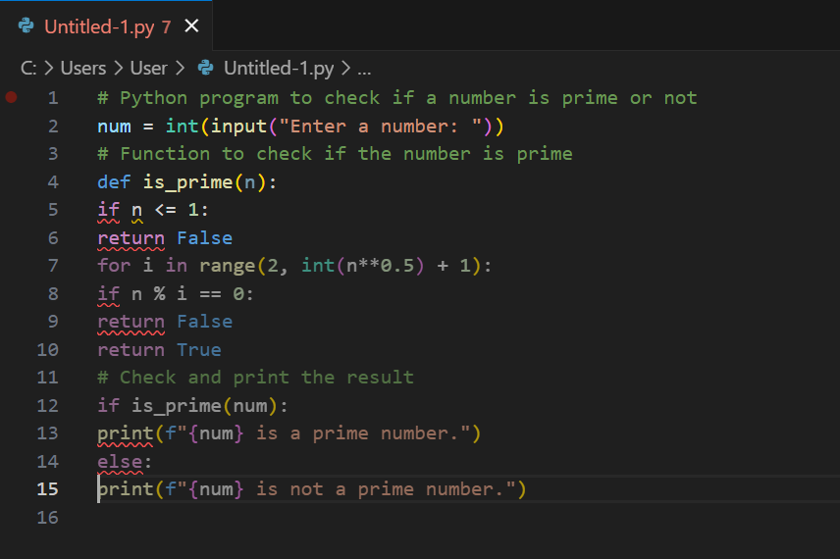
INPUT:
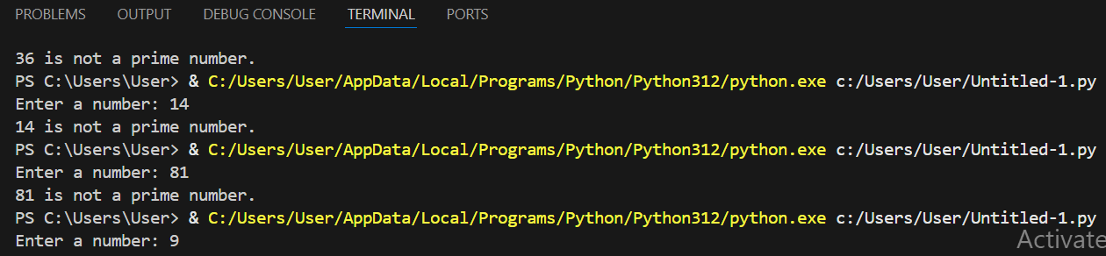
OUTPUT:

TASK 03

Write a Python program that prints numbers from 1 to 10 using a
While loop. Modify the while loop to print only even numbers
Between 1 and 20?
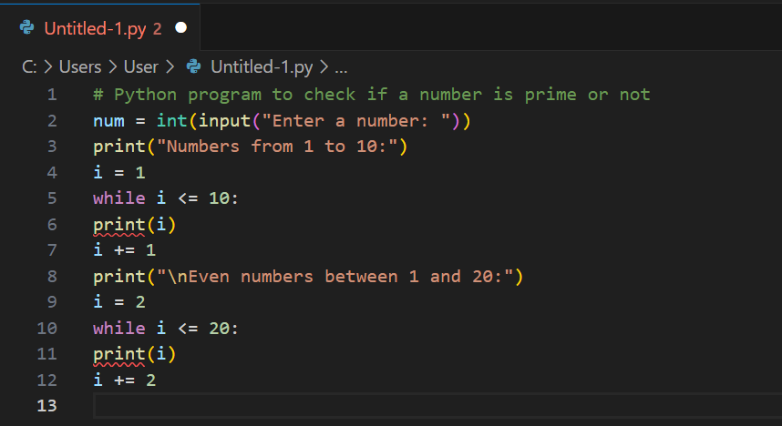
INPUT:
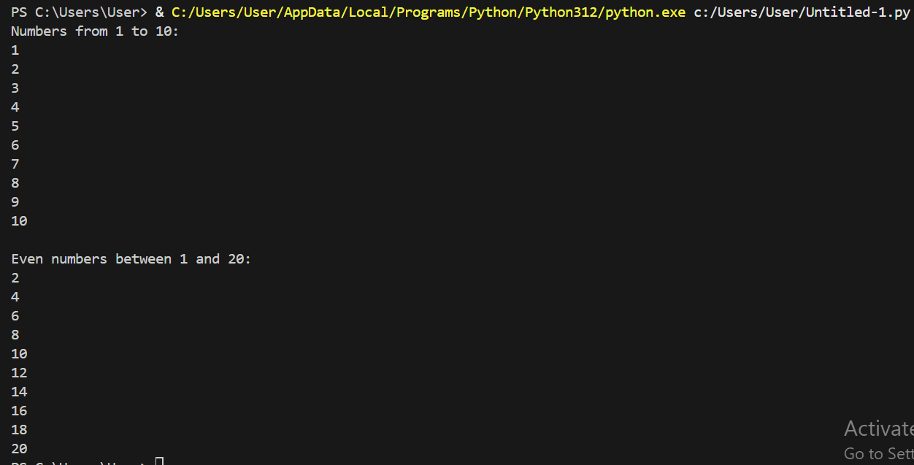
OUTPUT:

TASK 04

Write a Python program to determine whether the given number
Is a Harshad Number. If a number is divisible by the sum of its
Digits, then it will be known as a Harshad Number?
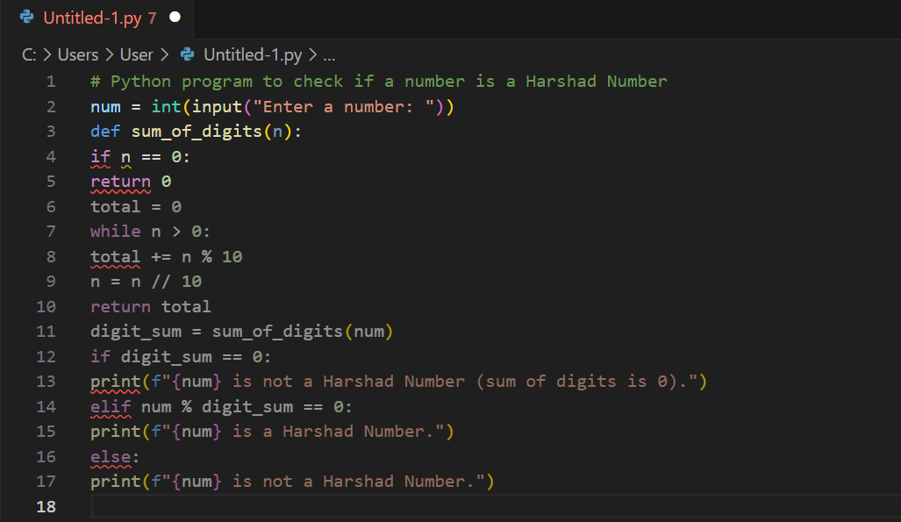
INPUT:

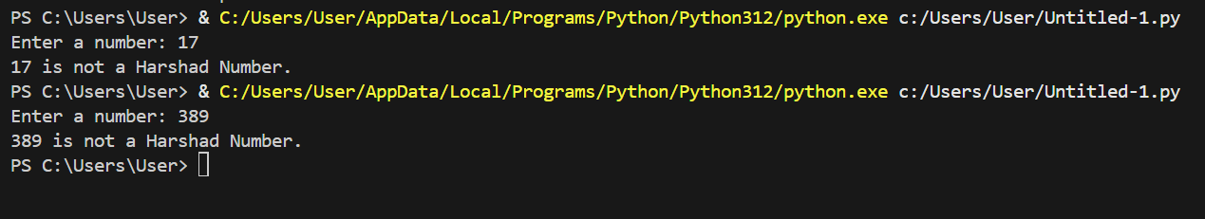
OUTPUT:

CONCLUSION:

In this lab, we have learned the basics of basics of Python programming, including loops, conditionals, and taking input from the user. We have been able to practically implement programs like printing tables, checking
Prime numbers, Harshad numbers, and how to use while loops. This have helped us in understanding python language usage for simple mathematical operations along with enhancing the logical thinking.

